Tepla M4L Asher
SOP
System Description and materials notes: The MetroLine/IPC M4L Plasma Processing System is a batch-mode plasma system for etch, strip,clean, and surface treatment. Gases include Oxygen, CF4 and Argon. The M4L generates a low pressure, low temperature gaseous plasma. Up to 600W RF energy is applied to a set of electrodes to separate some of the gas molecules inside the chamber into chemically reactive atoms, ions, and free radicals.

Safety
- High Voltage - High Voltage Radio Frequency is used throughout the system. System maintenance may only be performed by NRF Staff. Do not remove any tool covers or defeat any interlock on this system.
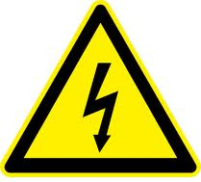
Covers: DO NOT remove any covers or touch any lead wires to avoid electrical shock.

- HOT: Wafers can be very hot when removing from the reaction chamber. Allow the wafers time to cool prior to handling.
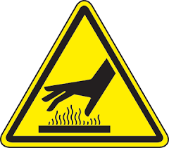
- Emergency Shutdown Procedure
Depressing the Emergency Off (EMO) located at the front and rear of the machine will instantly de-energize and remove all power to the system.

- Restrictions
  - None

- Operation

  - Touch the touch screen with your finger or use the stylus lying on the keyboard to wake up the monitor.
  - On the Run screen, verify that the box to the right of the “Hibernate” button is yellow. This indicates the chamber is pumped down. If yellow, press the “Hibernate” button. The will vent the chamber to atmosphere. It takes about 30 seconds. The system does not tell you when vented just be patient.
  - Open the chamber door. Note: each time this system is vented, the door must be left open until you hear the N2 purge turn off (about 5 seconds). If you open and close the door quickly, it will not run a process.
  - Lay your samples face up directly on shelves 1,2, or 3. Note: The bulk PR removal rate for shelf #2 is approximately 30% lower than shelves 1 and 3. If you have more than 6 whole wafers to run, shelves 1 and 2 may be removed to accommodate a quartz cassette of wafers. If you do remove shelves, place them on the work table and replace them when you are done. The pics below shows which shelf type (biased or grounded) is placed in which position.
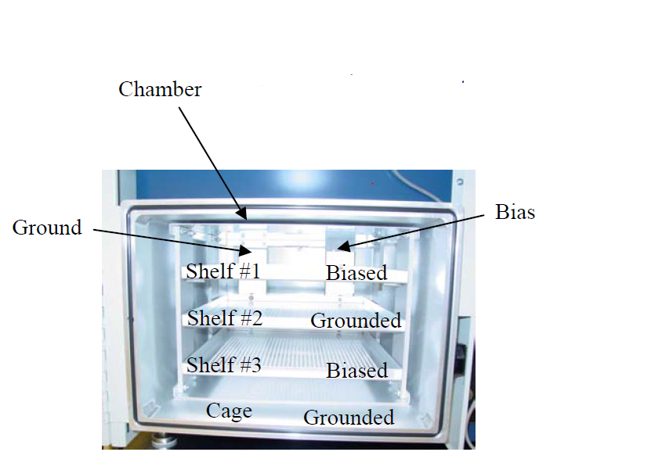
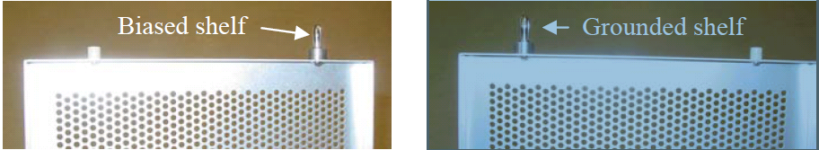

  - Close the chamber door.
  - Touch “Recipe” and double touch the directory for the gas desired, i.e. O2, Argon, CF4…
  - Select the recipe you desire and OK to load it. The recipe name includes the basic process parameters. Recipe “150W_300_1m” would mean 150 watts RF, 300sccm, 1 minute process time. If a recipe does not exist for the time you want, select the recipe without time parameter at the end of the recipe name, i.e. “150W_300”.
    - Editing a recipe time. To edit the recipe time, select “Maintenance and Process”. Then select “Recipe Designer” which will open the “Recipe Builder” screen. In the “Step Functions” box, click the >>>>>right arrow to step 3. In the “Terminator” box, Change the process time. Select “Save” in the center of the screen. When the pop up window opens, select CANCEL. This will save it for the currently loaded recipe but not to the recipe on the hard drive.
    - Exit the recipe builder screen.
  - Return to the “Run Screen” and click the “Run” button. Answer YES and input a sample number. The recipe will execute.
  - Watch the recipe while it. When the RF power comes on, check for high reflective voltage. If the reflected power is high, press and hold the rear toggle switch (push the toggle toward the rear/back of the tool) located inside the hole on the left side of the tool for 5 seconds and release it. See below. If the RF still has an issue tuning, call staff.
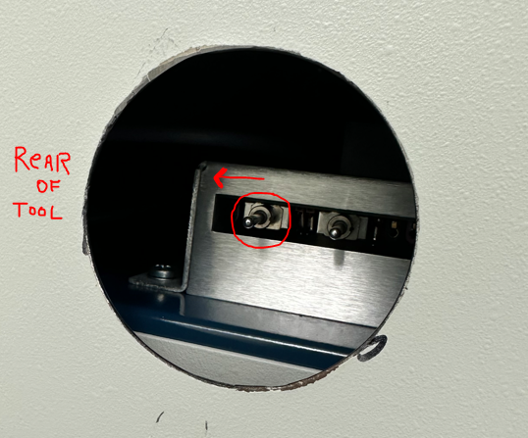
  - When the process is complete, a message will appear in the “Recipe Status” window and you’ll hear 2 beeps.
  - Open the door and unload your samples.
  - When done, close the door and leave it vented. Do not place in hibernate mode.
  - Log off the Tumi.

